

**INSTRUCTIONS FOR PROPER USE BY PEOPLEFACTS CLIENTS**

**Authorization for Employment**

As an employer and user of consumer reports, it is your responsibility to ensure compliance with all of the relevant federal, state and local laws governing this area. This SAMPLE form is provided solely as a courtesy and should not be construed as legal advice. It is important that prior to using this or any form, you consult with your OWN legal counsel to ensure that this form is properly prepared and construed in a way that is appropriate for your organization.

Once you have reviewed this SAMPLE form and made all appropriate revisions to this form to the satisfaction of you and your legal counsel, you should replace the sections in red with your organization’s name before distributing this form. Once you have determined that your revised Form satisfies your business and legal needs, you may remove the watermark as follows:

1. Click anywhere on the second page
2. Click the PAGE LAYOUT tab from the tool bar
3. Click the Watermark button
4. Click REMOVE WATERMARK from the Watermark menu
5. Delete/Remove this “Instructions for Proper use by PeopleFacts Clients” page.

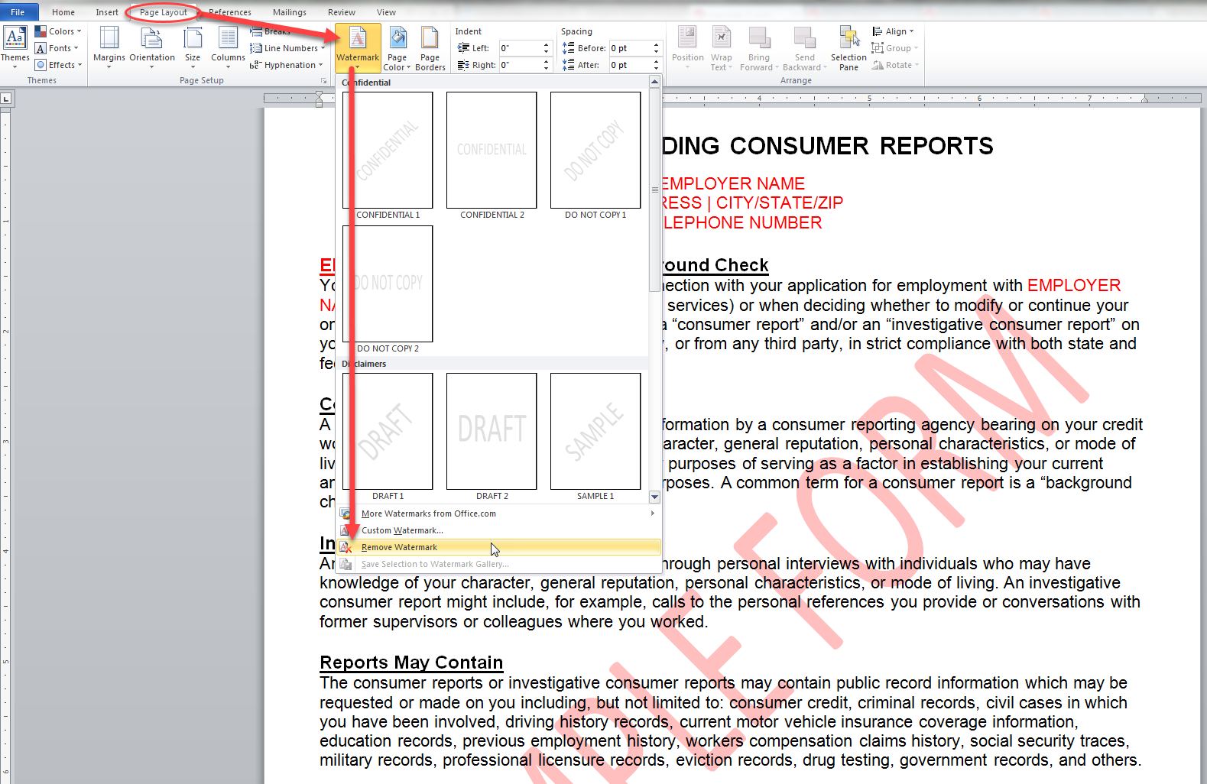

**DISCLOSURE REGARDING CONSUMER REPORTS**

EMPLOYER NAME  
ADDRESS | CITY/STATE/ZIP  
TELEPHONE NUMBER

**EMPLOYER NAME Will Obtain a Background Check**You acknowledge and understand that in connection with your application for employment with EMPLOYER NAME (including any independent contract for services) or when deciding whether to modify or continue your ongoing employment, if hired, we may obtain a “consumer report” and/or an “investigative consumer report” on you from PeopleFacts, a consumer reporting agency, or from any third party, in strict compliance with both state and federal law.

**Consumer Report Defined**  
A consumer report is any communication of information by a consumer reporting agency bearing on your credit worthiness, credit standing, credit capacity, character, general reputation, personal characteristics, or mode of living which is used or expected to be used for purposes of serving as a factor in establishing your current and/or continuing eligibility for employment purposes. A common term for a consumer report is a “background check report.”

**Investigative Consumer Report Defined**  
An investigative consumer report is obtained through personal interviews with individuals who may have knowledge of your character, general reputation, personal characteristics, or mode of living. An investigative consumer report might include, for example, calls to the personal references you provide or conversations with former supervisors or colleagues where you worked.

**Reports May Contain**

The consumer reports or investigative consumer reports may contain public record information which may be requested or made on you including, but not limited to: consumer credit, criminal records, civil cases in which you have been involved, driving history records, current motor vehicle insurance coverage information, education records, previous employment history, workers compensation claims history, social security traces, military records, professional licensure records, eviction records, drug testing, government records, and others.

You further understand that these reports may include experience information along with reasons for termination of past employment. You also acknowledge and understand that information from various federal, state, local and other agencies which contain information about your past activities will be requested, and that a consumer report containing injury and illness, drug testing, or other medical records and medical information may be obtained only after a tentative offer of employment has been made.

**Your Rights as a Consumer**  
You are hereby notified that you have the right to make a timely request for a copy of the scope and nature of the above investigative background report and/or a complete copy of your consumer report contained in PeopleFacts’ files on you at the time of your request by providing proper identification.

You are further notified that, prior to being denied employment based in whole or in part on information obtained in the consumer report, you will be provided a copy of the report, the name, address and telephone number of the consumer reporting agency and a description in writing of your rights under the Fair Credit Reporting Act. Correspondence to PeopleFacts should be forwarded to:

PeopleFacts | Consumer Relations | 4500 S. 129th East Avenue | Suite 132| Tulsa, OK 74134  
1-800-600-8999 | Support@PeopleFacts.com

**AUTHORIZATION TO OBTAIN CONSUMER REPORT**

The following is accurate and complete information required in order for EMPLOYER NAME to request PeopleFacts to perform a background check on you and in the process obtain a complete consumer report about you:

Full Legal Name : 

*(First Name, Full Middle Name, Last Name)*

All Previously Used Former or Other Names: *(AKA, Maiden Names, Married Names, Surnames, Etc.)*

Current Street Address:

City: State: Zip:

Prior Street Address 1: Dates Resided Here: _______ to _______

City: State: Zip:

Prior Street Address 2: Dates Resided Here: _______ to _______

City: State: Zip:

Prior Street Address 3: Dates Resided Here: _______ to _______

City: State: Zip:

Current Email Address*: Gender**: M / F Race**:

Social Security Number: Date of Birth**:

Driver’s License Number:  Issuing State: Expiration Date:

**Your signature below indicates the following:**

1. You authorize, without reservation, PeopleFacts or any third party to obtain and/or furnish to EMPLOYER NAME any records or information referenced in the provided disclosure statement for employment;
2. You authorize EMPLOYER NAME ongoing procurement of any records or information, reports and records at any time during your employment to the extent allowed by law;
3. You authorize the use of a fax or photocopy of this authorization as having the same authority as the original;
4. You authorize and request, without reservation, any present or former employer, school, police department, financial institution, division of motor vehicles, consumer reporting agency, or other entity, person or agency having knowledge about you to furnish EMPLOYER NAME and/or PeopleFacts or any of either of their affiliated entities with any and all background information in their possession regarding youfor these stated employment purposes;
5. You understand and agree that in connection with your employment your consumer report information, whether investigative or otherwise, may be shared with and/or reviewed by all applicable parties involved in the hiring process;
6. You have read and fully understand the foregoing disclosure and this authorization.
7. You certify all the information you have provided on this form is true, complete, correct and accurate; and
8. You certify you have received, reviewed and understand the “Summary of Your Rights under the Fair Credit Reporting Act (15 U.S.C. §1681 et seq.)” which is published by the Federal Trade Commission to help you know your rights.

**APPLICANT/CONSUMER Signature**: Date:

*\*Your email address will be provided to notify you when any adverse public record information is being reported.*

*\*\* This information will be used for background screening and record matching purposes only.*

**NOTICE REGARDING BACKGROUND CHECKS**

**AUTHORIZED BY A MINNESOTA, OKLAHOMA, CALIFORNIA, MAINE APPLICANT/EMPLOYEE**

|  |  |
| --- | --- |
| 🞎 | **Check this box if you are a Minnesota, Oklahoma, or California applicant**, and you would like to receive a copy of your consumer report, if one is obtained. For **California** applicants only: a copy of your report will be sent to you by the above-referenced employer within three business days beginning on the date of receipt by the employer. For **Minnesota** applicants only: the consumer reporting agency shall furnish a copy of your consumer report within twenty-four hours of providing it to the above-referenced employer. For **Oklahoma** applicants only: the consumer reporting agency shall furnish a copy of your consumer report. |

|  |
| --- |
| **CALIFORNIA APPLICANTS:** Pursuant to § 1786.22 of the California Civil Code, you may view the file maintained on you by PeopleFacts during normal business hours. You may also obtain a copy of this file, either in person or by mail, by submitting proper identification and paying the costs of duplication services. You may also receive a summary of the file by telephone upon production of adequate identification. PeopleFacts is required to have trained personnel available to explain your file to you and any coded information contained therein. You may appear in person alone, or with another person of your choice, provided that this additional person furnishes proper identification.  California Civil Code section 1786.16(2) requires a separate disclosure and authorization to be signed by an applicant or current employee each time a background check is performed for employment purposes. This requirement does not apply in situations where the employer has a suspicion of wrongdoing or misconduct by a current employee. |

|  |
| --- |
| **MAINE APPLICANTS:** Pursuant to Maine state law, § 1317(2), PeopleFacts is required to reinvestigate any consumer dispute made by a consumer residing in the state of Maine within 21 calendar days of notification of the dispute by the consumer |

**NOTICE REGARDING BACKGROUND INVESTIGATION**

**PURSUANT TO CALIFORNIA LAW**

EMPLOYER NAME (the “Company”) intends to obtain information about you for employment purposes from an investigative consumer reporting agency or consumer credit reporting agency. Thus, you can expect to be the subject of “investigative consumer reports” and “consumer credit reports” obtained for employment purposes. Such reports may include information about your character, general reputation, personal characteristics and mode of living. With respect to any investigative consumer report from an investigative consumer reporting agency (“ICRA”), the Company may investigate the information contained in your employment application and other background information about you, including but not limited to obtaining a criminal record report, verifying references, work history, your social security number, your educational achievements, licensure, and certifications, your driving record, and other information about you, and interviewing people who are knowledgeable about you.

The results of this report may be used as a factor in making employment decisions. The source of any investigative consumer report (as that term is defined under California law) will be PeopleFacts, 4500 S. 129th East Avenue | Suite 132| Tulsa, OK 74134. The source of any credit report will be PeopleFacts, 4500 S. 129th East Avenue | Suite 132| Tulsa, OK 74134. The Company agrees to provide you with a copy of an investigative consumer report when required to do so under California law.

Under California Civil Code section 1786.22, you are entitled to find out from an ICRA what is in the ICRA’s file on you with proper identification, as follows:

* In person, by visual inspection of your file during normal business hours and on reasonable notice. You also may request a copy of the information in person. The ICRA may not charge you more than the actual copying costs for providing you with a copy of your file.
* A summary of all information contained in the ICRA’s file on you that is required to be provided by the California Civil Code will be provided to you via telephone, if you have made a written request, with proper identification, for telephone disclosure, and the toll charge, if any, for the telephone call is prepaid by or charged directly to you.
* By requesting a copy be sent to a specified addressee by certified mail. ICRAs complying with requests for certified mailings shall not be liable for disclosures to third parties caused by mishandling of mail after such mailings leave the ICRAs.

“Proper Identification” includes documents such as a valid driver’s license, social security account number, military identification card, and credit cards. Only if you cannot identify yourself with such information may the ICRA require additional information concerning your employment and personal or family history in order to verify your identity.

The ICRA will provide trained personnel to explain any information furnished to you and will provide a written explanation of any coded information contained in files maintained on you. This written explanation will be provided whenever a file is provided to you for visual inspection.

You may be accompanied by one other person of your choosing, who must furnish reasonable identification. An ICRA may require you to furnish a written statement granting permission to the ICRA to discuss your file in such person’s presence.